Vermont Youth Conservation Corps
Trail Network Development and Management Plan
February 17, 2011

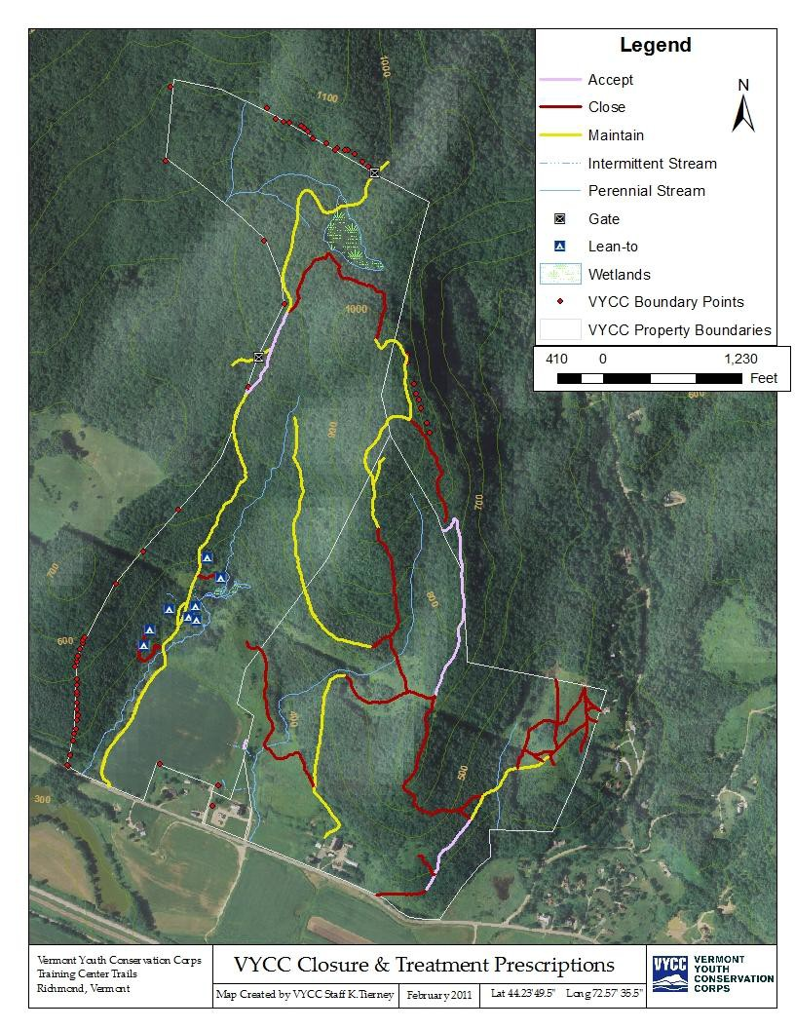
These two trails, slated for closure, were widened significantly in the past year.
There are four significant trails (orange dashes) that are not on the map What is planned for them?

Contents
Introduction 6
History 6
VYCC History 6
Property Acquisition 6
Relation to Other Management Plans 8
Trail Design Background 8
Design Approach 8
Purpose of Trail Plan 9
Goals and Objectives 9
Planning Process 9
Existing Resources 9
Current Conditions of the Physical Landscape 10
Stakeholder Input 13
Other Considerations 13
Identify control points 14
Paper concept 15
Trail classification 15
Implementation Plan 17
Construction Standards 17
Sustainable design 17
Materials Selection 18
Existing Trails Priorities 18
Maintenance 18
Closures 18
Rehabs 19
New Trail Construction Priorities 19
Lower loops 19
Spur trails 19
Upper loops 20
Maintenance Plan 20
Trail monitoring 20
Annual Maintenance 20
Appendix A 21
Appendix B 22

Introduction

History

VYCC History

The Vermont Youth Conservation Corps (VYCC) is a statewide, year-round, non-profit conservation and education organization with the mission of teaching individuals to take personal responsibility for their actions. Each year the VYCC enrolls over 200 Corps Members, aged 16-24, to work, live, and study together in small groups. All of our crews complete priority conservation, agriculture, park management, and disaster relief projects throughout Vermont and beyond under the guidance of highly trained leaders.
Since 1985 the VYCC has provided young people from every county and nearly every town in Vermont the opportunity to gain valuable natural resource training and education. The VYCC has completed millions of dollars worth of priority conservation work in Vermont through partnerships with state and federal agencies, municipalities, and like-minded conservation organizations. Examples of common project partners include: the Vermont Department of Forests, Parks, and Recreation, Vermont Agency of Transportation, Natural Resources Conservation Service, U.S. Fish and Wildlife Service, Environmental Protection Agency, U.S. Forest Service, National Park Service, and Vermont's Green Mountain Club, The Nature Conservancy, The Catamount Trail, Vermont Area Snow Travelers (VAST), and The Cross Vermont Trail Association.

Property Acquisition
Through the first 15 years of its life, the VYCC grew its programming and refined its practices as a leader in statewide youth employment, conservation, and trail work. In 2000 the VYCC identified a need to have a centralized statewide youth leadership, education, and training center to help streamline its operations and provide a platform for future growth. The VYCC emerged from an exhaustive series of visioning, planning charettes, and feasibility studies in a partnership with the Richmond Land Trust and developed a vision to purchase and rehabilitate a property in Richmond, Vermont.
This property was acquired by the VYCC in two distinct purchases: 232.5 acres from the Wheeler Family via the Richmond Land Trust (RLT) in 2005; and 166.4 acres from the Vermont Farm Bureau in 2008.

The initial purchase was made with the West Monitor Barn on the brink of collapse after years of disuse. The VYCC, in partnership with the Richmond Land Trust, conducted a $3.7 million capital campaign, culminating in the purchase of the West Parcel, the historically accurate restoration of the barn, and development of the VYCC’s headquarters office, education, and training center in the West Monitor Barn.

In 2008 the Vermont Farm Bureau prepared to sell its land and ownings at the East Monitor Barn. For the
VYCC the potential threat of conflicting uses and opportunity to expand its current education and training center to include the East Monitor Barn and associated buildings was too great an opportunity to pass up. The VYCC reached a purchase and sale agreement with the VFB in April of 2008. This sale included all buildings and lands of the East Parcel.

Together these parcels now represent a property of approximately 400 acres that are under the management of the VYCC and are a critical part of the vision for the VYCC’s future as a statewide leader in conservation, education, and youth employment training.

An integral piece of the future expansion of the VYCC is the continued improvement of trail building skills and techniques. Therefore, the VYCC set out with intentions of improving on existing trails and constructing new trails on its property. The first few years of land ownership were a learning experience for the VYCC as different individuals from VYCC’s Headquarters staff made efforts toward the stewardship of the land. The result of these initial efforts was a disjointed approach at repair of existing trails and construction of new trails. As a result many repairs were completed to the same segment of trail year after year and new trails that were laid-out were quickly abandoned or re-routed.

Relation to Other Management Plans
The VYCC property is managed for agricultural, forestry, educational, and recreational purposes. In addition to this Trail Plan the VYCC has developed an Agricultural Plan and has an active Forestry Plan that outline specific plans and treatments into the future. These plans are brought together under the overall VYCC Land Management Plan, which serves as a unifying document.

The Land Management Plan is reviewed and updated as needed by VYCC staff with subsequent reviews of the plan completed by the Richmond Land Trust and the Vermont Housing and Conservation Board. When that review is completed the VYCC’s sub-management plans (i.e. Trails, Agriculture, and Forestry) shall be updated as well with revised maps, documentation of work completed, and review of the vision forward for the subject matter of each plan.

The trail plan shall be updated with information as follows:
- Work completed – work shall be documented with the VYCC’s standard work project accomplishment forms. Each for shall be filed as an appendix to this document.
- Funding received – grant applications shall be documented in list form with a brief description and saved to the VYCC’s existing server locations for funding sources. All funds awarded shall be documented as an appendix to this plan with an assurances statement and a copy of the grant award letter (or agreement).
  - Appendix A – 2009 and 2011 Recreational Trails Grant Program Funding

Trail Design Background

Design Approach
When designing a trail there are critical steps to take to ensure that the design results in a sustainable trail system that provides user group benefits in the long term. As simply put those critical steps break down as follows:

- Identify goals
- Study available resources
- Study the physical landscape
- Identify control points
- Create paper concept design
- Create implementation plan
- Create maintenance plan

This plan will follow an outline that roughly parallels these steps.

Purpose of Trail Plan
The purpose of the VYCC Trail Plan is to establish a clear vision for a trail system on the VYCC property providing long term direction to VYCC Headquarters Staff, and other interested parties, in the design, construction, and maintenance of the trail system. The Trail Plan establishes priorities, outlines a construction schedule, and provides guidance in sustainable design/build standards for the trails on VYCC’s property. With this purpose in mind the following goals have been established for the VYCC property:

Goals and Objectives
- Develop a sustainable multi-use trail system that serves the needs of the public non-mechanized community
- Provide a recreational resource that offers a number of trail options, including loop trails, a variety of trail lengths, routes to views, and landmarks
- When pertinent, meet ADA specifications on accessible sections of trail and lean-tos
- Use the construction and maintenance of the trail system as a training opportunity for staff
- Highlight a variety of trail construction structures and methods, as well as showcase VYCC technical capabilities
- Offer a research location for the VYCC, partnering organizations, and graduate researchers in such topics as trail design and ecology

Planning Process
The Trail Plan is the result of an extended period of investigation and familiarization with the VYCC property. Throughout this process VYCC Headquarters Staff, Bradley Materick and Keegan Tierney spent considerable time gathering resources, identifying and beginning management of current uses on the property, identifying stakeholders, and assessing current conditions on the property.

Existing Resources
Numerous resources exist that relate to the development of the VYCC’s trail system. These resources provide background knowledge and in some cases lead to direct considerations for the Trail Plan related to design and layout.

GIS resources
Various GIS resources have been accessed and utilized in planning the VYCC’s trail system. These include Aerial photos, USGS contour maps, Richmond Town Parcel boundaries, Chittenden Country Conserved Land data, wetlands data, wildlife habitat data, and directly gathered GPS data from the VYCC property.

Wildlife assessments
Sue Morse of the organization Keeping Track spent time on the VYCC property identifying and documenting significant wildlife habitat with VYCC Staff Members. This information will be used to guide the layout of trails and their relative proximity to various wildlife features.

Existing utility easements
Green Mountain Power and Vermont Electric Power Company hold transmission line easements that cross the VYCC property. These lines are located directly along Route 2 and bisecting the middle of the property running east/west. The utility easements provide some restrictions related to built structures such as lean-tos, privies, and other backcountry lodging.

Existing land use easements
There are currently two easements on the VYCC property encompassing 276.5 of 398.55 acres. These easement restrict development of the property in various ways, however both leave room for the development and construction of trails for bipedal use. For full details on easement restrictions and language please refer to the VYCC’s Land Management Plan.

Current Conditions of the Physical Landscape

Current conditions:

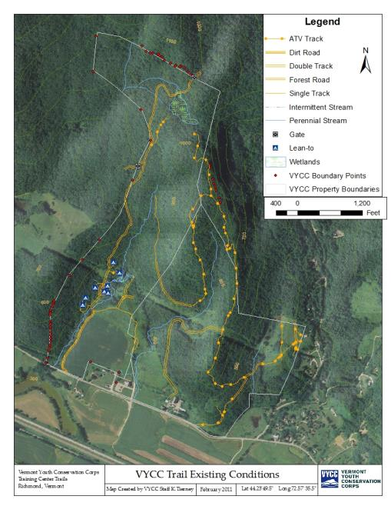
Historically the VYCC property was used widely and intensively in agricultural production. Similar to the landscape around much of New England the property was cleared in the 1800’s for sheep farming and it subsequently moved into dairy production. There was an active dairy on the property from the late 19th century through the 1980’s. This intensive use has left the land with an intersecting network of old agricultural roads, forestry roads, and livestock paths that are still significant features on the land today.

The major arteries on the existing network of roads and paths were historically
accessed by the
general public
for recreational ATV use. ATV users kept existing forest roads cleared and open, however they did not complete any erosion control measures. In addition these forest roads were not designed to be used as high impact ATV corridors and many have degraded to a state where they are beyond reasonable repair.

When the VYCC acquired the property it took an initial step of constructing eight lean-tos to serve as a base for its residential staff training events that occur during the spring and summer. Some existing forest access roads were used to access the lean-to location and small spur trails were developed to the various lean-tos. These trails initially started as paths to carry construction materials into the site and have slowly evolved into more developed trails.

An extensive effort was made to survey and document the condition of the existing forest roads on the land. This information was collected by using GPS data and has been compiled into a solid base dataset by VYCC headquarters staff. Map 1 documents the extent of the existing forest road trail network on the VYCC’s land.

The existing forest road trail network was then assessed for condition, sustainability, and compatibility with VYCC’s long term trail goals. The assessment analyzed the following elements of each trail: tread stability, existing structures, slope (cross-, out-, and overall), regular maintenance needs, current uses/users, and location on property relative to trail system goals. Based on this assessment the following list of treatment recommendations has been developed: acceptable, need maintenance/management, or recommended for closure. These treatment recommendations are outlined on MAP 2

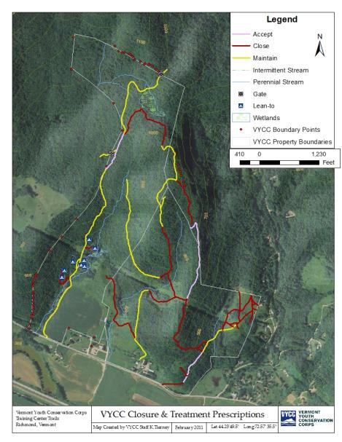
A benefit of the field assessments that were conducted of the trail network was that VYCC Headquarters Staff developed a thorough first-hand
knowledge of the lay of
the land. This has helped to inform trail system design decisions when working toward an
initial paper concept as
outlined in this plan.

VYCC Use
Currently the VYCC land is used primarily as an educational tool for our two main programs; the Conservation Program and the School Partnership Program. The Conservation Program hosts an experiential based residential staff training on the property in the spring time and it places summer conservation

crews on the land. The primary focus of this program is to teach youth valuable job and life skills through work based crew experiences. The School Partnership Program centers educational lesson plans around work projects based on the land. This program places high school students together for work based educational lessons in various aspects of natural resources, conservation, and agriculture.

Public Use
When the VYCC took ownership of the property there was widespread use of ATV’s on many forest roads on the property. This use has been effectively negated. There is a steady public user group that accesses the property for both bipedal and equestrian uses. These individuals primarily use the East Side Path and climb to the power line clearing overlooking the Winooski River Valley. Additionally the property is widely used by hunters for turkey and deer hunting and occasionally for bear, partridge, squirrel, and other small game hunting.

Currently the VYCC does not publicize its trail system due to the incomplete nature of the existing forest roads and the lack of directional signage. The VYCC plans to create some initial shorter loop trails that will be marked with directional and educational signage at which point the trails will be publicized for use. The VYCC has been in communication with the Richmond Trail Committee about being incorporated into their trail literature at that time.

Stakeholder Input
The VYCC conducted a series of stakeholder meetings to help gain an understanding of various stakeholders’ priorities for the management of the VYCC property. The stakeholders represented were VYCC Headquarters Staff, VYCC Field Staff, VYCC’s Board of Directors, the Richmond Land Trust, and various neighbors. An overwhelming majority of stakeholders were interested in trail development and maintenance for public access. With that strong direction the VYCC plans to publicize its trails to public use as soon as possible. There were a number of other priorities that stakeholders weighed in importance ranging from protection of wildlife to utilizing the land as a public recreational resource.

Other Considerations

Wetlands
A portion of the Boundary Trail Area contains wetlands and a vernal pool. While this will generally not
be a consideration in the winter, summertime use of the trails within wetlands may require the use of
boardwalks and/or other forms of tread hardening. Some seasonal closure of trails may be necessary in extremely wet or sensitive areas. There is tremendous interpretative potential surrounding the vernal pool areas. All trail development in excess of ½ acre which involves placement of fill within the wetland areas will require a Corps of Engineers wetland permit.

Stream Crossings
There are several minor stream crossings within the proposed trail network as well as numerous gullies
which will hold water or may be extremely soft during wet seasons or periodic rainfalls. Stream
crossings will be minimized to the extent possible to reduce potential impacts on riparian zones. Crossings that are determined to be necessary will be designed to have stable abutments located outside of the active flood plain to prevent streamside/flood plain erosion and minimize the risk of bridge washouts due to flooding.

Crossings of small gullies, seeps, and depressions can be addressed by a variety of techniques appropriate to each site. These include the use of cross drains, culverts, water permeable gravel fill, and simple lumber bridge or puncheon structures. If practical, existing trails may be rerouted in order to bypass these unsustainable trail locations and new trails will be designed to avoid these locations.

Connection/access to adjacent properties
The VYCC does not have current plans to develop or maintain any trails that cross neighboring
landowner’s property lines. The one exception is the Vermont Association of Snow Traveler’s
(VAST) trail, which crosses VYCC Property. The VYCC has had a history of granting VAST permission to
maintain and utilize a trail corridor passing through the northwest corner of the property. The maintenance of this trail is currently the sole responsibility of VAST. Any improvements or substantive changes to this corridor need to be approved by the VYCC prior to initializing work.

Wildlife Habitat/ Ecological Considerations
One section of the forest near the trail network has been identified as prime bobcat habitat.
Recommendations from local wildlife biologists will help determine appropriate trail alignment with an
effort to minimize impact on this predator’s habitat. There are various locations on the property where the topography consists of steep ledges and talus slopes. These locations have been identified as prime habitat for a variety of species including bobcat.

Historic Elements
Any man-made rock walls that cross the trail network should not be dismantled for use or passage. Trails should be re-routed accordingly to keep the walls intact and materials should be harvested elsewhere. If relocation is not possible the stone wall shall be crossed without disturbing its historic nature. Old barbed-wire fencing should be carefully wound up and removed. Discarded farming materials should be left?

Identify control points
Control points are places on the property that are of direct relevance to a trails system for the reason that the trail must go there or must avoid that point. An example would be a known bobcat den site. This would be seen as a control point that it is important for a trail to avoid. Stakeholders were asked to identify system wide control points that they thought were relevant to the VYCC trail system. The following details those control points:

▪ East Monitor Barn
The East Monitor Barn (EMB) and related facilities are being developed as the heart of the VYCC educational camps. The EMB will serve as a practical trail head, parking area, and education point for trail users.

▪ West Monitor Barn
The West Monitor Barn is the VYCC’s existing headquarters training center and office space. It is proximate to the Monitor Barn Farm vegetable operation and serves as a secondary trail head, parking area, and education space for the trail system.

▪ Lean-tos
The Lean-tos are the VYCCs primary residential program training space and are frequently used in the spring and summer seasons by VYCC programs. They need a direct connection to the West and East Monitor Barns.
▪ North Wetlands
The North Wetlands have been identified as an area of ecological importance. They contain critical wildlife habitat and have been identified as a fragile ecosystem. Trails should minimize contact with the wetland while providing educational opportunities about the ecosystem.
- ▪ Geographic high point of property
The high point of the property has been identified as a natural destination for trail users. It is located near the eastern property line and existing trail approaches will have to take into consideration these property boundaries.
- Property Lines
The VYCC is open to developing connections to trails that lead off its land. The VYCC also respects private landowners rights to limit access to their property and thus at this time does not have any plans to develop or maintain trails that leave the VYCC’s property with the exception of the VAST trails crossing the northeast corner of the property.

Talus Slopes
There are three locations on the VYCC property that can be truly defined as Talus Slopes, which serve as critical habitat for sensitive wildlife. The VYCC plans to avoid these areas with a 100- foot buffer zone

Paper concept
A concept vision for the VYCC Monitor Barns trails system was created by a committee of VYCC Headquarters staff with representation from the Operations and Program departments in an effort to make the project inclusive of perspectives from: project development, the Conservation Program, the School Program, facility and land use, technical skills, and administrative perspectives. A final draft of the master plan was also reviewed by the president of the organization who brings a development and funding perspective to the process of the ongoing trail planning.

Initial layout and design of a trail network was accomplished by synthesizing the information gathered in the investigation phase, identifying positive and negative control points, and completing a draft layout of a trail network using topographic maps to ensure sustainable construction practices would be followed.

Trail classification
The VYCC plans to construct, maintain, and manage trails for bipedal use including hiking, running, snowshoeing, and cross country/backcountry skiing. Trails will be classified as summer, winter, or year- round use and will fall into three development categories: Universally Accessible, developed, and remote. These classifications are used on the initial paper trail plan (Map 3)

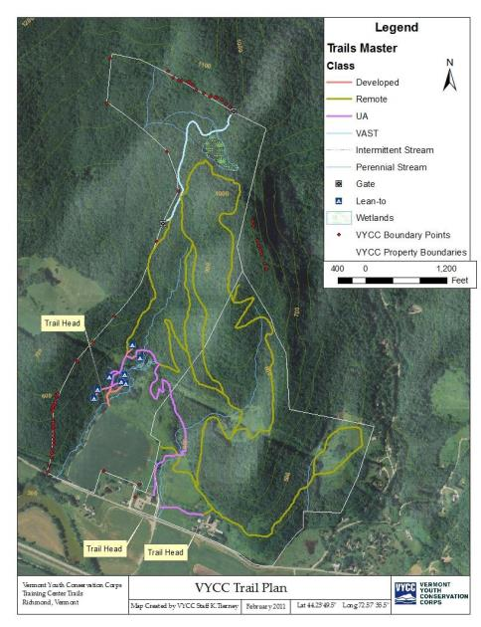
Universally Accessible The American Board of Architects has defined standards for the design, construction, and maintenance of Universally Accessible trails. These standards have been adopted by various federal agencies that are responsible for the management of trails, including the US Forest Service. The VYCC plans to include universally accessible trails on its property with the goal of creating accessible trail between the two monitor barns and extending to the Lean-to area.

Developed
The VYCC defines developed trails as trails that are designed for high, heavy-impact use. Examples of this type of trail include the spur trails system at the lean-to area and the trail from the West Monitor Barn to the East Monitor Barn.

Remote
The VYCC defines remote trails as trails that extend onto the land for the light recreational use including hiking, running, snowshoeing, and cross country skiing. These trails are designed to move people around the land for the purposes of recreation and education.

Implementation Plan

Construction Standards

Sustainable design

Design vs. Structures

Slope Rules:
Slope is used to determine the steepness of a trail and is typically calculated by taking the vertical
distance (rise) of a trail and dividing it by the horizontal distance (run). As an example, if a trail rises 10
feet over a distance of 100 feet, the slope would be 10/100 which equals 0.10. This number if usually
multiplied by 100 and presented as a percentage e.g. 10%. You may also find slopes written as ratios such as 1:20 or even as an angle such as 30 degrees. The VYCC prefers to use percentages when describing slope.

Rule of 5’s
As a rule of thumb, the VYCC abides by the 5/10/15 rule. This rule states that no out slopeshall be greater
than 5%, the average running grade of any trail should be 10%, and no slope shall exceed 15% without
the construction of a special structure such as a staircase. Although this rule may be difficult to follow in certain situations, it is extremely important for trail sustainability and longevity, especially when working with highly erodible soils.

½ rule
The ½ rule is used when calculating maximum slope on a trail. The ½ rule states that the maximum slope of the tread should not exceed ½ of the slope of the terrain which the trail is built upon. This is especially important on topography with gentler grades. For example if you are building a trail on a hillside with a 7% slope your maximum trail grade should not exceed 3.5%. This rule supersedes the rule of 5’s in this situation.

50% Rule
Additionally, the VYCC has adopted the 50% rule which refers to the back slope created from a bench cut. Whenever possible, back slopes should be cut to a 50% slope (45 degree angle) to reduce the amount of soil sloughing off into the trail. Forty-five degrees is the angle of repose for many soils (the maximum angle of a stable slope determined by friction, cohesion and the shapes of the particles).

Resources
The VYCC uses three primary resources when planning, designing and building trails. When used in combination these three resources cover most of the trail design problems that may be encountered. All trails built on the VYCC property should follow the standards outlined in these manuals. They are:

- USFS Trail construction and maintenance manual
- SCA’s Lightly on the land
- Minnesota DNR’s Trail Planning, Design, and Development Guidelines

Materials Selection
Lumber:
Whenever additional materials are needed for structures, function and source will be considered. Any portion of the structure in direct contact with the ground (such as bridge sills) should be constructed of either pressure treated lumber or hemlock. This will reduce decay over time. Portions of the structure not in direct contact with the ground or water do not necessarilyhave to be specially treated. When available and cost effective, use of local lumber should be considered. Trex, or bridge decking made of recycled plastic, should also be considered, as it will last virtually forever without decay and have a lower environmental impact. On sections of trail where rustic aesthetics are preferred, natural wood should be used.

Rock:
Rock, when available, should be the first choice for structures that will be in direct contact with theground, such as turnpikes or staircases. It will last infinitely longer than a comparable wooden structure.

Geo-textile:
In some especially wet areas, geo-textile fabric may be employed to hold gravel and act as a solid, drainable foundation for a section of trail.

Hardware:
In general, if sections of a structure will ever need to be removed or replaced, screws should be used as fasteners. For example, bridge or boardwalk decking should use screws instead of nails. They should be galvanized. Nails should be used…

Existing Trails Priorities

Maintenance

West side path
The West Side Path is an existing former agricultural road that runs from the northwest corner of the agricultural fields through the VYCC’s lean-to area and up the hillside, eventually connecting with the VAST trail. The West Side Path is in need of erosion restoration measures, de-berming, and installation of drainage features to help prevent future damage. This path will remain open for use in future silvacultural treatments as well as for emergency egress from the upper portions of the property.

East side path
The east side path is a former agricultural road that leads from the East Monitor Barn complex up through a pine plantation and eventually connecting with the power line corridor. It needs some minor erosion control measures implemented, a small amount of de-berming, and installation of some drainage structures. The East Side Path will remain open for use in future silvacultural treatments as well as for emergency egress from the upper portions of the property.

Closures

Valley skid roads
The Valley Skid Roads are a series of agricultural and forestry roads that crisscross and wet valley basin. They will be closed and some active restoration will take place to decrease erosion, prevent inadvertent/unwanted future use, and encourage the restoration of the natural forest ecosystem.

Rehabs

Pine plantation path
The Pine Plantation Path runs adjacent to the base of one of the ledge slopes on the VYCC property. There is an existing agricultural road that passes through a large stand of white pine trees and accesses an open field and wetland on the east side of the VYCC property. This path is in good condition needing only minor maintenance and installation of one small stream crossing.

New Trail Construction Priorities

Lower loops

Lunchtime loop
The lunchtime loop has been constructed. It serves as the primary route up the middle of the property (with the West Side Path and East Side Path being the other two routes to access the VYCC uplands. The Lunchtime Loop was constructed in 2010 by the VYCC’s Conservation Program leaders in the spring spike training.

Lean-to Trails
The Lean-to trails need a variety of maintenance and in some cases decommissioning. This is outlined on the lean-to detail map (Map 4). The Lean-to trails are being reconstructed as developed trails as they receive high impact at vulnerable times of the year (i.e. spring, early summer, and late fall). These trails will serve the primary purpose of keeping the rest of the lean-to area pristine and undisturbed by high foot traffic.

Wetland ski
The Wetland Ski is a winter only trail that is a loop based at the end of the Pine Plantation Path. It loops around an open field and then crosses over the top of a small wetland. The wetland ski needs ocorridor clearing and marking.

Spur trails

Outdoor classroom
The Outdoor Classroom spur trail is a trail that will lead from the East Monitor Barn complex to an open field on a plateau above Rt. 2. It will be constructed by the school program as they are the primary users of the outdoor classroom.

High Point
The High Point trail is a spur trail off of the Forest Wetland Loop that accesses the highest point on the VYCC property. In the spring summer and late fall it provides excellent views of Camels Hump and the Winooski Valley. The trail will be new construction possibly utilizing small sections of existing forest roads.

Winooski Valley Overlook
The Winooski Valley Overlook is a short spur constructed to Universally Accessible Standards. It provides a viewing point over the Monitor Barns Farm and the Winooski valley

Upper loops

Forest Wetland Loop
The Forest Wetland Loop is the longest trail on the VYCC’s property. It will extend from the top of the East Side Path to the backside of the VYCC property visually accessing a forest wetland before re-joining the Lunch Time Loop to link back to the Monitor Barns.

Perimeter Loop
The Perimeter Loop is a trail that will depart and re-join the Wetland loop trail. It will provide an extended hiking option and create the longest loop on VYCC property.

Maintenance Plan
Maintenance of trails and structures is just as important as the actual construction. Proper attention paid to on-going functionality of structures and trails will ensure that they remain in good condition for as long as they were intended to! Annual cleaning out of drainage structures will keep them functioning for years; if they are not maintained, they can become tripping hazards or actually cause more erosion. Following is a plan to ensure that proper assessment and maintenance is carried out on the VYCC trail system

The VYCC Facilities Manager and Land Management Committee will be responsible for oversight of maintenance plans for the VYCC Trail Network. The Facilities Manager will also be responsible for communicating work project goals and schedules to the crews; will serve as the Project Sponsor.

Trail monitoring
Each spring, the VYCC Facilities Manager will conduct an annual assessment of the trail network and identify priority work for the upcoming season through both written record and flagging. Things to note:
- Failed drainage structures
- Recently developed wet areas that are not draining properly
- Rotting bridge, boardwalk, sign or kiosk components
- Blow-downs or snags
- Missing or faded trail markers

Annual Maintenance
Each spring and fall, a School Crew will perform a walk-through to clear blow-downs, brush back any overgrown vegetation, and trim low-hanging branches. They will also clean debris from all drainage structures, including water bars, drainage dips and culverts, and off bridges and boardwalks. Rock structures will be checked for stability by dancing on top of them. If rocks wiggle, they need to be replaced or reset until firm. This work will be consistent with the VYCC Trail Standards outlined in other sections of this plan.

VYCC School Crews should dedicate about three weeks in the spring and 4 weeks in the fall to trail maintenance projects. On-site Conservation Program crews will divide their seven-eight week sessions between trail and agriculture work. Conservation Crew Leaders will help maintain and construct the VYCC trails during the technical skills portion of staff training (1 week each May).

Appendix A

2009 and 2011 Recreation Trails Grant Program Funds

The VYCC received two recreation trails grants in 2009 and 2011, respectively. These grants were awarded to construct and upgrade trail segments as identified in the map provided with the grant materials (on file and available on request from the VYCC)

They VYCC has provided landowner permission via signed letter in the grant applications and as result of this appendix provides assurance that the trail shall remain open, maintained, and available for public use consistent with stated purpose of the trail as defined in the grant application and the VYCC Trail Plan for the useful life of the investment, which is a minimum of ten years for this project. If the trail ceases to remain open and available for public use for the minimum of ten years, the sub recipient (VYCC) shall be responsible for reimbursing the state and/or federal funds to the State of Vermont.

If the VYCC passes ownership of the property or ceases to exist the Richmond Land Trust (RLT), as easement holders, will ensure that the trails remain open, maintained, and available for public for the above stated minimum timeframe.

By signing below the VYCC and Richmond Land Trust agree to the above assurances.

Thomas Hark, VYCC Founding President Date

Fritz Martin, RLT Board Chair Date

Appendix B

2013 Recreation Trails Grant Program Funds

The VYCC was awarded a Recreational Trails grant in 2013 for construction of a Universally Accessible Trail proceeding from the barn to the grassy knoll overlooking the farm fields and Winooski Valley. This work is identified in the map provided with the grant materials (on file and available on request from the VYCC)

They VYCC has provided landowner permission via signed letter in the grant applications and as result of this appendix provides assurance that the trail shall remain open, maintained, and available for public use consistent with stated purpose of the trail as defined in the grant application and the VYCC Trail Plan for the useful life of the investment, which is a minimum of ten years for this project. If the trail ceases to remain open and available for public use for the minimum of ten years, the sub recipient (VYCC) shall be responsible for reimbursing the state and/or federal funds to the State of Vermont.

If the VYCC passes ownership of the property or ceases to exist the Richmond Land Trust (RLT), as easement holders, will ensure that the trails remain open, maintained, and available for public for the above stated minimum timeframe.

By signing below the VYCC and Richmond Land Trust agree to the above assurances.

Thomas Hark, VYCC Founding President Date

Fritz Martin, RLT Board Chair Date

Full details of this information can be found in Appendix A

