DRAFT Stewardship Monitoring Report

Property Information

(1) Name of Property: West Monitor Barn

(2) Property Ownership: RLT Private
If privately owned, record name and address of current owner:
Name(s): Vermont Youth Conservation Corps (VYCC)
Address: 1949 East Main Street, Richmond, Vermont 05477
Contact Name & Phone #: Jeremy Schleining: 802.434.3969, jeremy.schleining.vycc.org

(3) Has there been a change in ownership since last report? Yes No
If Yes, include recording information below:

Visit Report

(4) Date and Time of Inspection: Monday 10/30/2013, 8:30am-10:30am

(5) If privately owned, was owner contacted prior to visit (if yes how)? Yes No
I met with Jeremy Schleining, VYCC Property Manager in person prior to the visit.

(6) Did owner (or representative) accompany the monitor? Yes No
VYCC representative Jeremy Schleining accompanied me.

(7) Describe how the land is currently being used (in restricted area only). Give specific detail about agricultural and forest uses if applicable:
The property covers approximately 233 acres. Most of the upper elevations of property are forested. There is little merchantable timber on the property. Lower elevations are primarily open field, agricultural (~35 acres of which ~18 acres serves as cattle pasture, and ~12 acres for vegetable gardens and greenhouse), the West Monitor Barn and parking. Vegetable farming operations continues to expand as the landowner now operates a production farm. Eight lean-tos and a composting toilet have been installed along the west side of the property in the tree line just above the old field.

(8) Monitor’s best assessment of whether the terms of the conservation restrictions are being observed: (if No, explain below or on attachment) Yes No
It appears that the terms of the conservation restrictions are being observed except in terms of recreational ATV activity.

(9) Did you note any possible violations of the terms of the conservation restrictions:
(if Yes, explain below or on attachment) Yes No

As noted in item eight above, recreational ATV activity has been reported on the property, sign of ATV usage was found on the conserved portion of the parcel where a foot trail had been widened in 2011 to accommodate ATV travel (site #1 on attached map). Additionally, ATV tracks were again found in sensitive, wet soils on the East Monitor Barn parcel (figs 1-2, site #2 on attached map). During the 2011 and 2012 monitoring tours ATV usage was identified in the same locations as well as further up the slope on the West Monitor Barn parcel.

ATV activity appears to stem from an agreement that VYCC has with a neighboring landowner, who has been given authorization to use an ATV on the property for the purpose of trail maintenance in exchange for recreational use of some trails.

In 2011 and 2012 VYCC was encouraged to develop a map that delineates all locations where motorized vehicle operation is expected for management purposes, the expected frequency of operations (e.g., hours/day and days/year), optimum trail conditions, etc. and where motorized vehicle operation is prohibited. Such a map could help minimize soil erosion and compaction, and could ensure that RLT and VHCB fully understand VYCC’s intentions regarding ATV usage on the property. That map has yet to be developed.

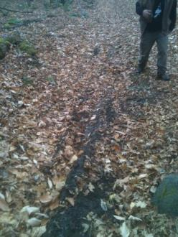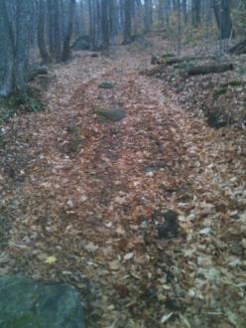
Figure 2. Close-up ATV track in sensitive, wet soils, EMB, 10/30/2013
Figure 1. ATV track in sensitive, wet soils, EMB, 10/30/2013
(10) General Remarks

- Property Management Plan: A draft land management plan for the property was circulated in 2011 for review and the Richmond Land Trust and I provided comments at that time. I have not been provided with a subsequent draft or a finalized plan since that time. The grant of development rights requires that RLT and VHCB review and sign-off on such plans before it can become final. A trail management plan for the property similarly remains in development.

- Trail Master Plan: While another new trail has been built on the property during the past year, the trail master plan for the property, begun in 2009, remains in development. VYCC is encouraged to provide a draft plan to RLT and VHCB for review prior to adoption the adoption of this trail plan.

- Forest Management Plan: The forest management plan for this property calls for thinning stand numbers four and five, and re-examining stand number three in 2009. As of this visit these prescriptions have not been implemented. VYCC is encouraged to work with its consulting forester and the County Forester to bring its forest management into compliance with its Current Use/Use Value Appraisal program agreement.

D. Trail maintenance and trail development: Another new trail crossing the property east to west has been built on the west parcel (site #3 on attached map). This trail should be mapped and included in new maps of the property. Also, two short bypass trails were added in 2013 to skirt particularly wet spots on the west side trail.
As noted in the previous monitoring reports, water diversion structures installed on the west side trail should be inspected every year or two and maintenance when needed (removal of debris/leaves) to ensure proper function. The upper portion of this trail would require a more systemic fix to address surface water flows. Neither of these are high priority items.

The 2007-2012 stewardship monitoring reports recommend installation of an ATV barrier at the northern end of the narrow—often wet—trail in the ravine between rocky ridges with significant wildlife sign (sites #5 and #6). If this isn’t feasible, consider taking other steps to prevent unwanted ATV travel through this section and to minimize erosion such as re-routing the trail. The ATV barriers are still recommended.

E. Invasive Exotic Plants: In 2007 the exotic, invasive shrub Japanese barberry (Berberis thunbergii) was found growing in the northwest portion of the property (site #7) and the largest plants were covered with a blue tarp. As recommended in 2007-2011 monitoring reports these plants and others in the area should be removed before they spread. Surrounding area should be checked for additional plants. Follow-up monitoring should occur for two-three years to ensure that dormant seeds haven’t sprouted.

Additional infestations of Japanese barberry and buckthorn (Rhamnus cathartica), an invasive exotic tree on the property (sites #8 and #9) were found in 2008. Actions were taken immediately and again in 2009 to remove these plants. These sites were not monitored or treated in 2010-2012. Resurvey and follow-up control are encouraged to prevent return.

F. Powerline Right-of-Way Management: Utility companies again cleared trees adjacent to the powerlines in 2013. The width of the powerline clearing on some sections of the property appears to be much wider than is warranted. VYCC is encouraged to review the right-of-way easements with the utilities holding the easements to verify that maintenance activities are within guidelines of the easement.

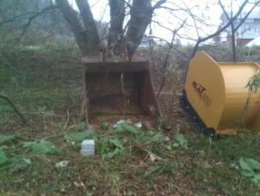
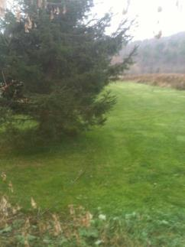
G. Cowles Encroachment
Neighboring landowner Mr. Craig Cowles continues to maintain a lawn north of the property line and north of a line of spruce trees planted to delineate the boundary (figure 3). This land could otherwise be included in the acreage assigned to production agriculture. Mr. Cowles has recently placed construction equipment on the VYCC of the property line immediately adjacent to the corner marker (figure 4 and site 10 on attached map).
Figure 4. Survey monument where VYCC and Cowles properties meet. Photo shows Cowles' construction equipment placed on VYCC's side of the property line.
Figure 3. Encroachment on conserved VYCC property at border between VYCC and Cowles properties. The line of trees is the approximate property line (Cowles property to the left, VYCC right) with the grassy area maintained as lawn by Mr. Cowles.

No other conditions were noted on the West Monitor Barn property that clearly appeared to be a violation of conservation restrictions were observed.

(11) Attachments (Note how many of each - leave blank if none):
4 Photos 1 Map ___Drawings __Appendix

___ Other (describe___________________________________________________

(12) Name of Monitor: Jon Kart

Signature: Date: 10/30/2013

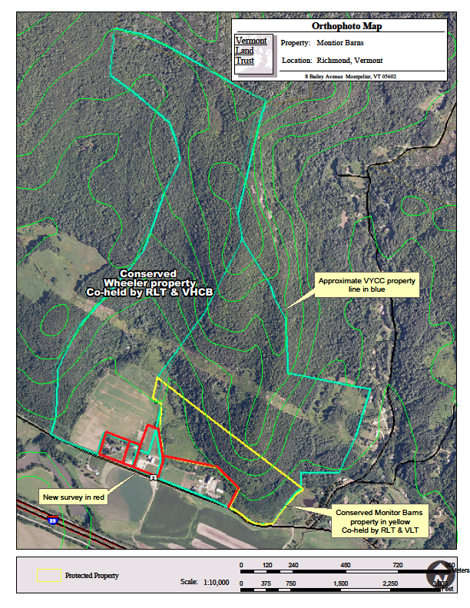
Stewardship Recommendations for the West Monitor Barn Property 2013 Base map from VLT
2. ATV tracks on un-conserved land in sensitive, wet soils. 2011
10. Encroachment by neighboring landowner. 2013
3. New Trail Improvement: Trail re-routed around perennially we site. .
1. ATV tracks/sign on conserved land.2011
4. Standing water at low spot in trail ~10m x 5m. Consider re-routing trail or raised-walkway.
8. Japanese barberry (B thunbergii) 2008

9. Buckthorn (R cathartica) 2008
7. Japanese barberry (Berberis thunbergii) infestation. Identified in 2007. It should be relocated and treated.
5. Steep, rutted, trail prone to erosion. Re-route to follow contours. Consider installing ATV barrier.

6. Narrow—often wet—trail in the ravine between rocky ridges with significant wildlife sign. Consider steps to reduce erosion and ATV access from trails connecting from the East Monitor Barn property.

