

**Stewardship Monitoring Report**

***Property Information***

**(1) Name of Property: East Monitor Barn Easement**

**(2) Property Ownership:** **RLT** **Private**

If privately owned, record name and address of current owner:

Name(s): Vermont Youth Conservation Corps (VYCC)

Address: 1949 East Main Street, Richmond, Vermont 05477

Contact Name & Phone #: Jeremy Schleining: 802.434.3969, jeremy.schleining.vycc.org

**(3) Has there been a change in ownership since last report?**  **Yes**  **No**

***Visit Report***

**(4) Date and Time of Inspection:** Monday 10/25/2013, 3:30-4:30pm

**(5) If privately owned, was owner contacted prior to visit** (if yes how)**?**  **Yes**  **No**

I contacted Keegan Tierney, VYCC Operations Director prior to the visit via email and telephone.

**(6) Did owner (or representative) accompany the monitor?**  **Yes**  **No**

VYCC representative Jeremy Schleining accompanied me.

**(7) Describe how the land is currently being used (in restricted area only).** **Give specific detail about agricultural and forest uses if applicable:**

The property under easement covers approximately 44 acres and is a mix of forest (white and red pine plantation, and red oak-northern hardwood forest) and old field.

**(8) Monitor’s best assessment of whether the terms of the conservation restrictions are being observed: (if no, explain below or on attachment)**  **Yes**  **No**

It appears that the terms of the conservation restrictions are being observed *except* in terms of ATV trail building and recreational ATV activity on the trail across the conserved portion of the parcel has increased and a foot trail has been widened to facilitate ATV use (see figure 1, and site #1 on the attached map).

**(9) Did you note any possible violations of the terms of the conservation restrictions?**

**(if Yes, explain below or on attachment)**  **Yes**  **No**

As noted in item eight above, a foot trail across the conserved portion of the parcel has been widened to an ATV trail and this trail appears to receive significant ATV usage (based on an assessment of vegetation growing in the trail and on a report from a third-party that regularly walks and monitors the trail). See figure 1, and site #1 on the attached map.

Section III. 12. of the Grant of Development Rights and Conservation Restrictions for the conserved parcel does not appear to authorize the development of trails for motorized recreational activities. That section reads as follows:  
  
*The right to clear, construct, and maintain trails for walking, horseback riding, skiing, and other non-motorized recreational activities within and across the Protected Property. Snowmobiling may be permitted at the discretion of the Grantor*   
[Grantor in this case refers to VYCC].

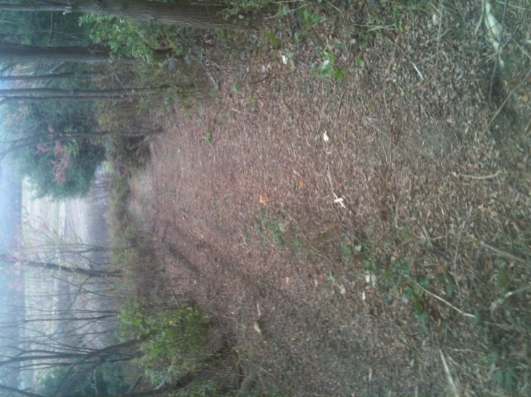

Figure . Foot trail widened for ATV use.

I have been told that a trail plan for the property is in development, but have yet to receive a copy for review. It is not known if this ATV trail is specified in the trail plan.

**(10) General Remarks:**

**Property Management Plan:** A draft land management plan for the property was circulated in 2011 for review and the Richmond Land Trust and I provided comments at that time. During the 2012 monitoring tour I was told by the VYCC Operations Director that the plan had been completed and that it would be forwarded to the Richmond Land Trust and the Vermont Land Trust for final review. As of 10/25/2013, I have not received a copy of that “completed” plan. I do not believe that the Richmond Land Trust (RLT) or the Vermont Land Trust (VLT) received copies either. The grant of development rights requires that RLT and VLT review and sign-off on such plans before it can become final. A trail management plan for the property similarly remains in development.

**Invasive Plants:** Infestations of the exotic, invasive shrubs Japanese barberry (*Berberis thunbergii*) and honeysuckle ((*Lonicera* species) were identified on the east side of the property over the past five years and reported in previous stewardship monitoring reports (see site #2 on map on page 3 of this report). Some progress was made in past years in controlling these infestations, but they remain in place. This area should be surveyed more extensively and remaining barberry and honeysuckle plants removed. Follow-up monitoring should occur for 2-3 years following removal.

**(11) Attachments** (Note how many of each - leave blank if none):

1Photos 1 Map **___**Drawings Other**____________**

**(12) Name of Stewardship Monitor:** Jon Kart

Signature: Date: 10/25/2013

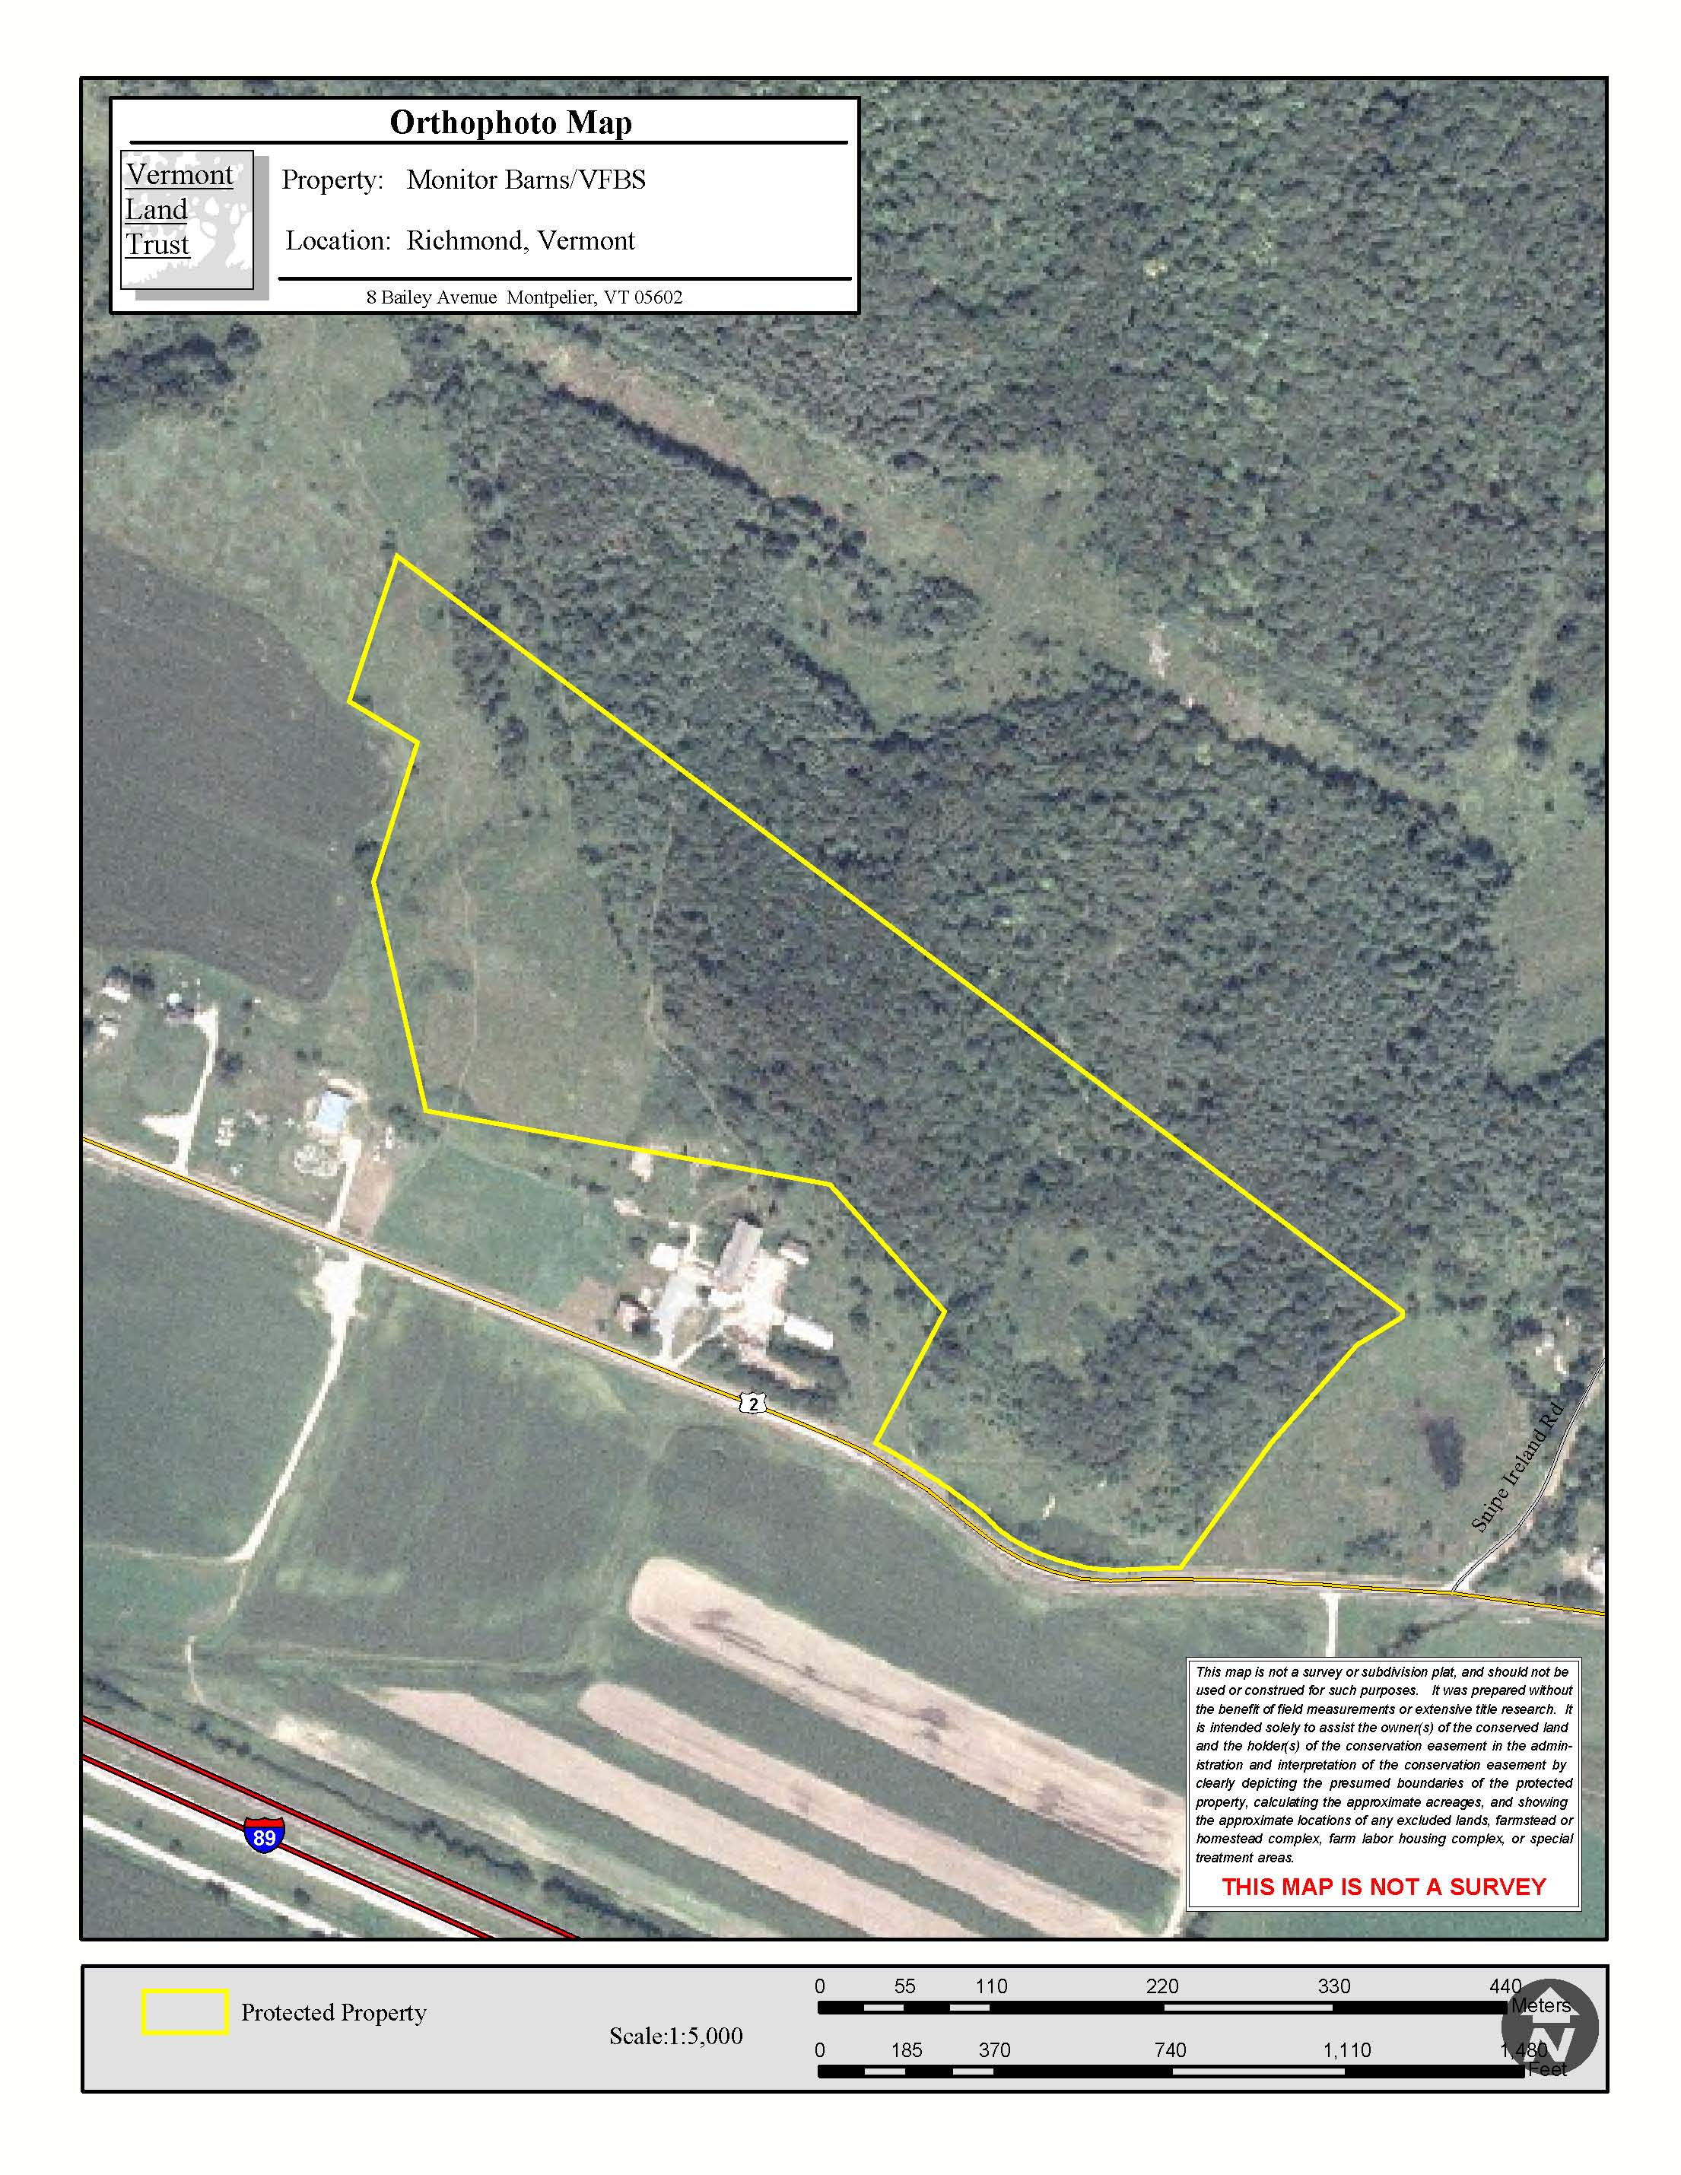

3. Path of 11/27/2013 vehicle intrusion. Added to report on 12/5/2013

1. Approximately path of foot trail widened to accommodate ATV access.   
Recreational ATV usage has been reported on this path

2. Japanese barberry (*Berberis thunbergii*) and honeysuckle (*Lonicera* species) infestations

**Stewardship Recommendations for the East Monitor Barn Easement Lands 2013**

*Base map from Vermont Land Trust Monitor Barn/VFBS orthophoto map*